Driven Racing Oil™ DR40 Semi-synthetic Turbo Diesel Oil
Huntersville, NC – The latest offering from Driven Racing Oil™ combines conventional 15W-40 viscosity with advanced synthetic mPAO technology to provide enhanced wear protection and shear stability for high-performance turbocharged diesel engines.
With the maximum level of ZDDP recommended for diesel engines, DR40 Turbo Diesel Motor Oil delivers outstanding protection for flat tappet cams, bushing lifters, cam driven fuel pumps, turbocharger bearings and cylinder bores. Plus, it is compatible with all exhaust after treatment devices and exceeds the API licensed requirements of the CJ-4 specification, as well as the performance criteria of API C-4 Plus, CI-4, CH-4, CG-4 and CF-4. DR40 is also compliant with original equipment manufacturer performance specifications, including Caterpillar ECF-3, Cummins CES20081, Detroit Diesel Power Guard 93K218, Mack EO-O Premium Plus, Renault VI RLD-3, Volvo VDS-4 and Ford WSS-W2C171-E. It can be used in naturally aspirated diesel engines.
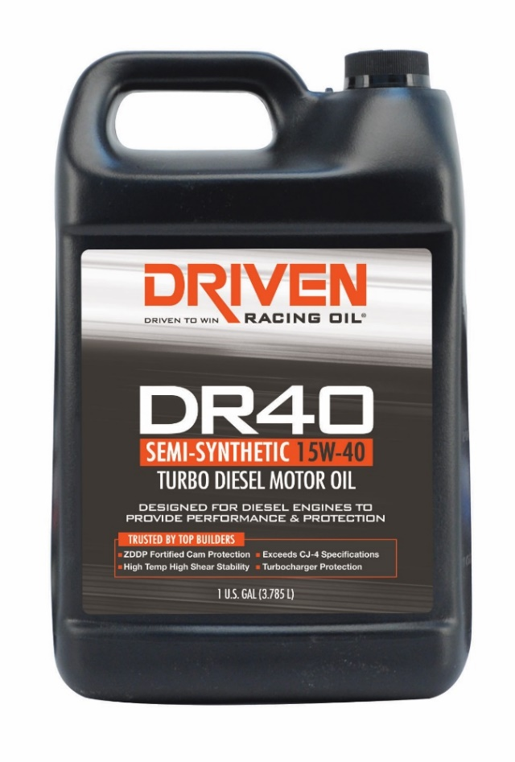
Part Numbers: #5408 (1 gal.) Price: $29.99
About Driven Racing Oil™
Driven Racing Oil™ utilizes cutting-edge lubricant technology and on-track research for maximum performance gains from all of its product offerings. Competition drives innovation, and Joe Gibbs Racing originally developed the Driven brand of oils to advance engine and driveline performance on the racetrack. From full-synthetic race oils to engine break-in oils and cleaners, Driven offers a wide range of race and street products that deliver performance, protection and value.

